So when you have Visual Studio 2019 and using VC++ compilers like MSVC () you will not create a Makefile when you run cmake. I’m guessing.

How to build Visual Studio on command line and inside Visual Studio 2019 GUI

After

**cmake ..**

type

**cmake –build .**

Or open Visual Studio 2019 , open *.sln solution file

Instead, after running cmake (with associated CMakeLists.txt) a *.sln is created (the *.vcproj tell you what build flags were set due to cmake…this is what replaces the Makefile)



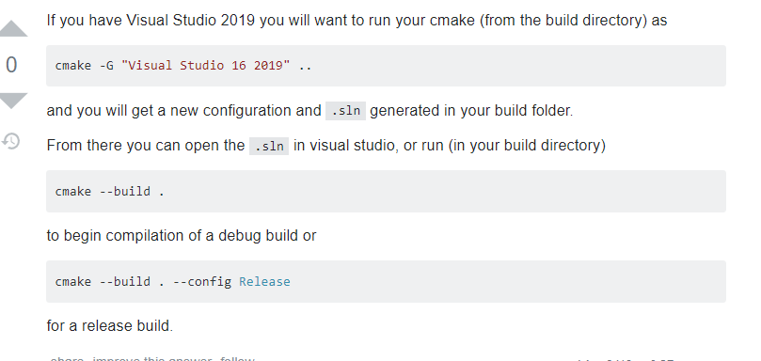

If you have Visual Studio 2019 you will want to run your cmake (from the build directory) as

cmake -G "Visual Studio 16 2019" ..

and you will get a new configuration and .sln generated in your build folder.

From there you can open the .sln in visual studio, or run (in your build directory)

cmake --build .

to begin compilation of a debug build or

cmake --build . --config Release

for a release build.